**Lab Assignment 5**

This is an application developed using Ionic framework which has Registration and Login functionalities. And a web mash up with two web services kairos and Speech to text. It also has text cases written and executed using karma and jasmine.

**Wire Frames:**

**Index Page:**

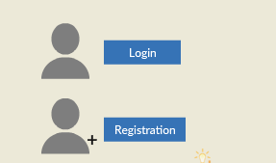

**Login Page:**

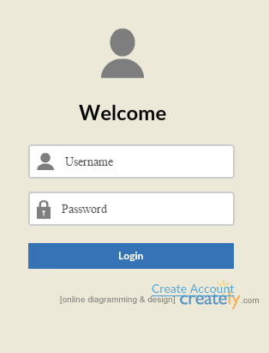

**Login Failure Page:**

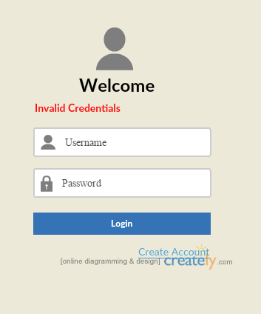

**Registration Page:**

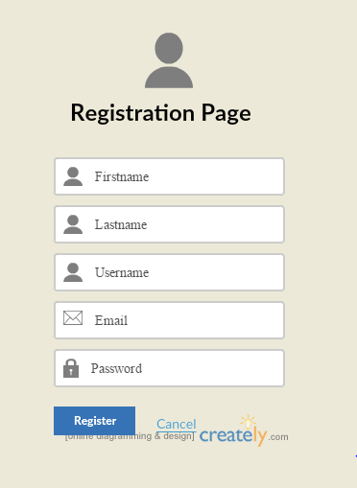

**Registration Success Page:**

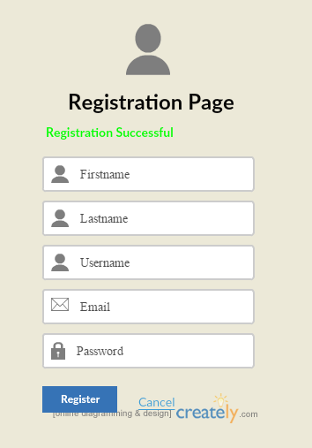

**Registration Failure Page:**

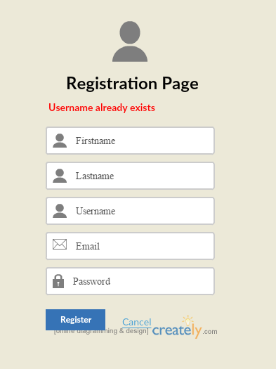

**Home Page:**

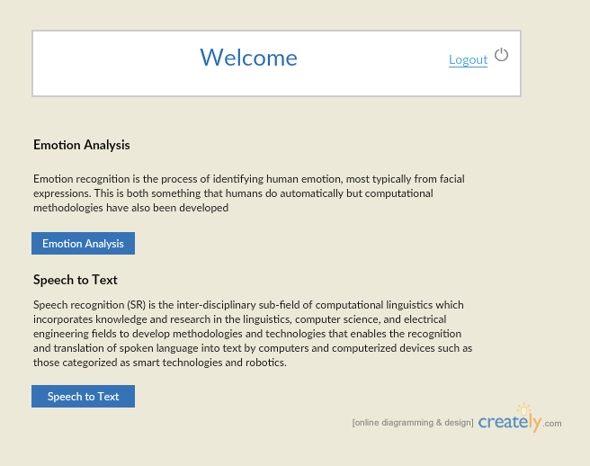

**Emotion Analysis Page:**

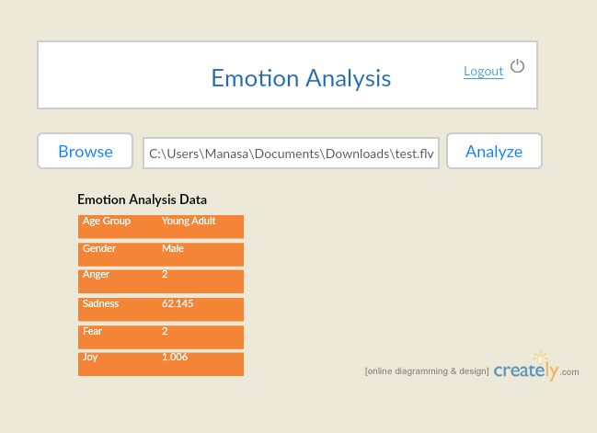

**Speech to Text Conversion Page:**

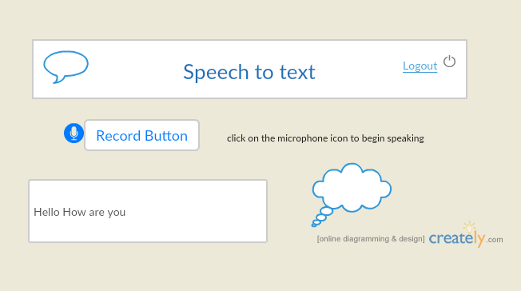

**Web Application Pages:**

**Index Page:**

This page contains two buttons Login and Registration. If you are a new user click on registration and register your details by filling the form and then click ‘Register’. If you are an existing user click on login and directly login with your credentials.

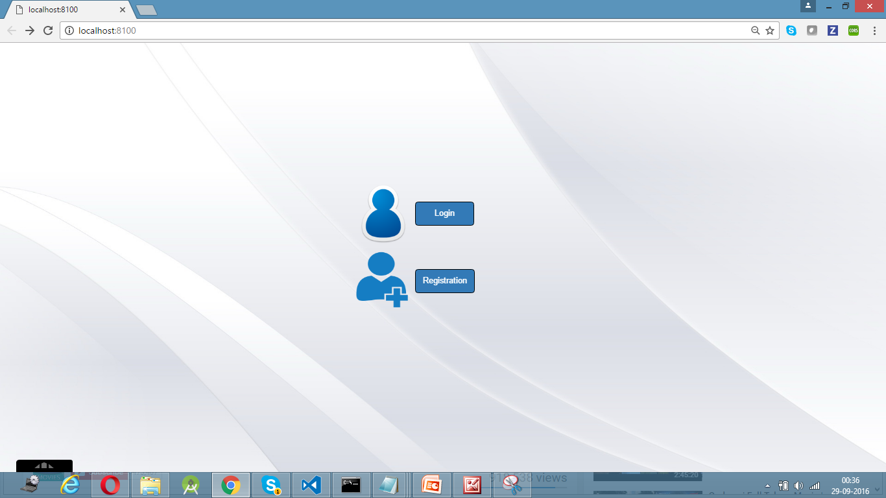

**Login Page:**

This is the Login page of the Web Application. This page contains two text fields to enter Username and Password. If you enter valid credentials and then click “Login” button it will direct to the Home page. If You click on Register Link it will direct to the Registration page.

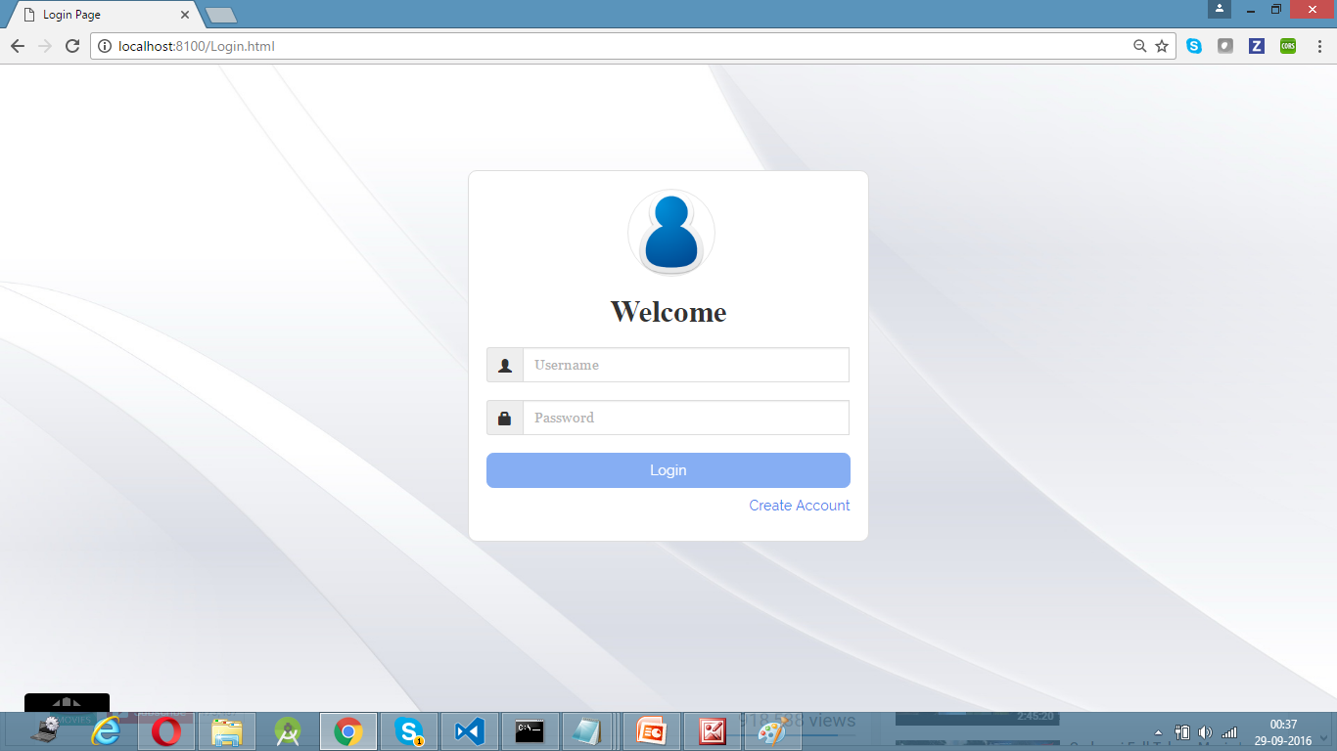

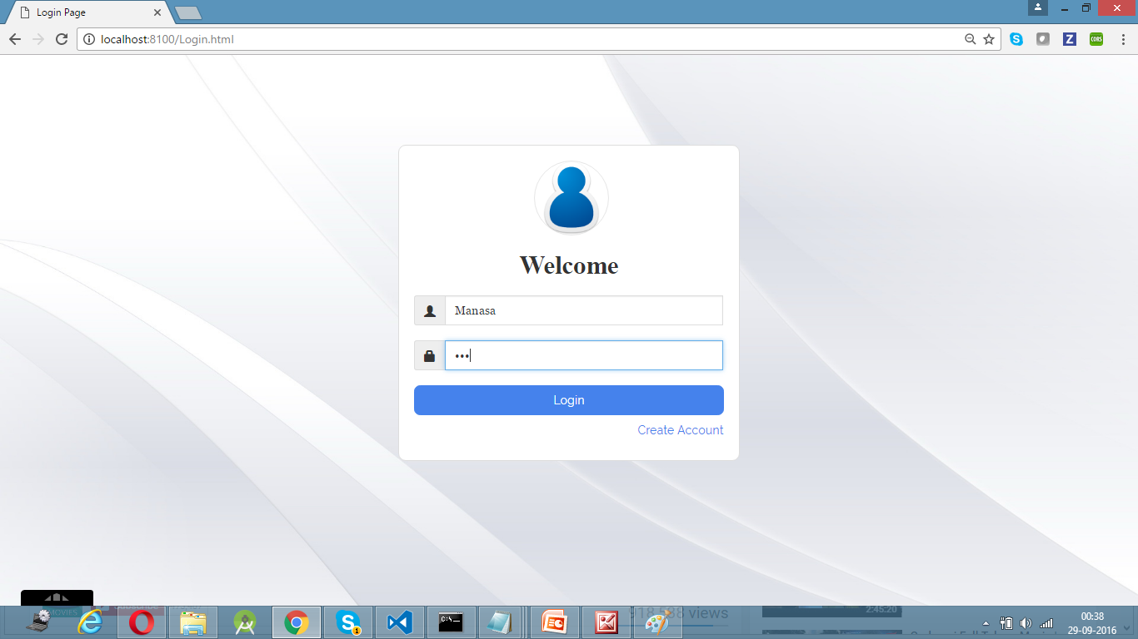

**Login Failure Page:**

If you enter Invalid credentials and try to login It will direct to the Login Page and Display a message stating that the credentials are invalid.

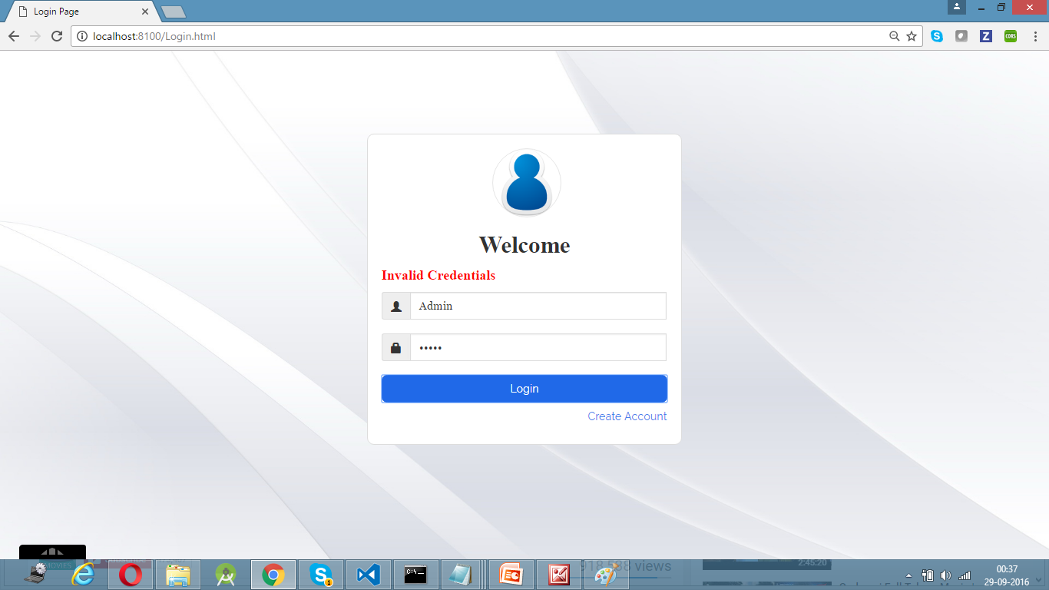

**Registration Page:**

If you are logging in for the first time if you click on register link in the Login Page it will get directed to the Registration Page. You have all your basic details and then click “Register”. If you want to cancel the Registration then click on “Cancel” lick which will direct to the Login Page.

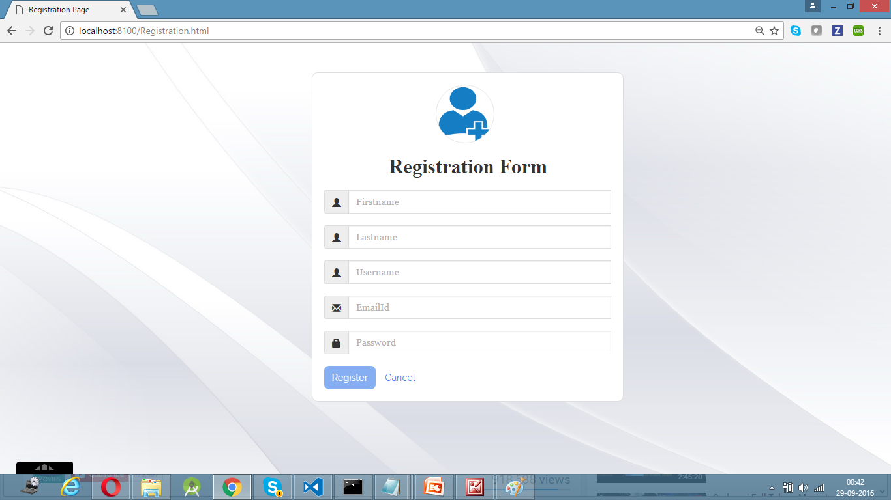

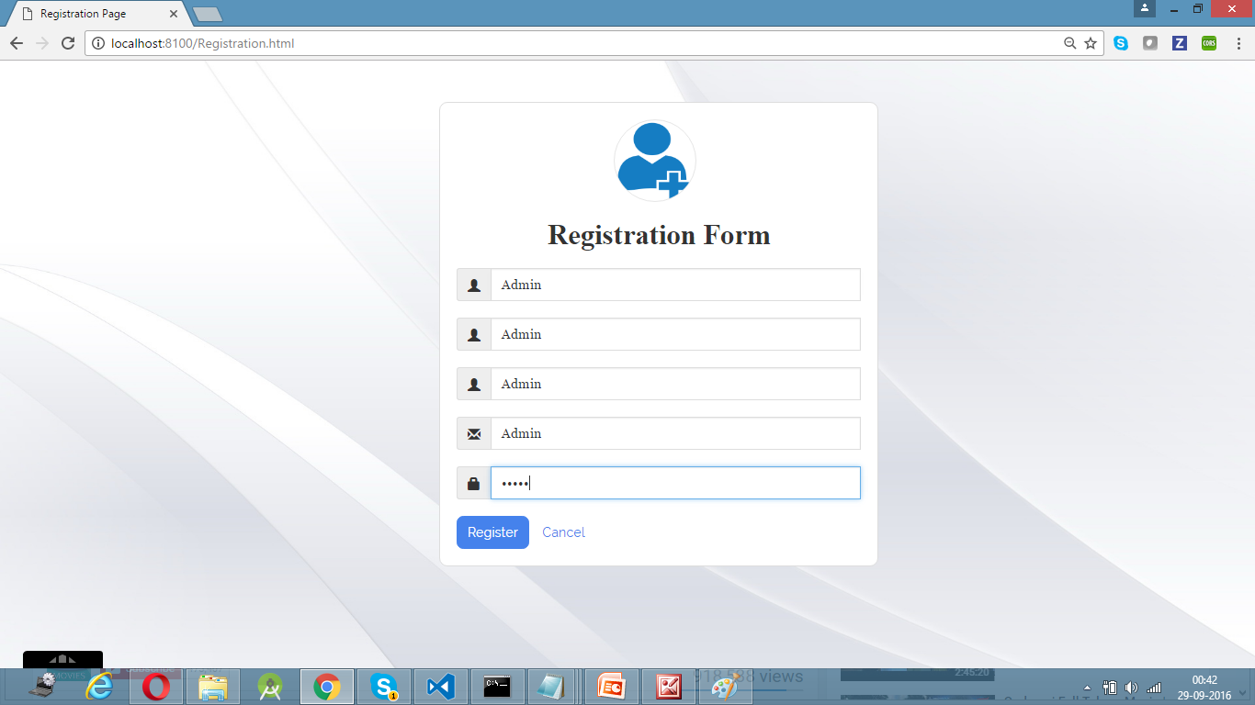

**Registration Success page:**

If you enter all the details and if there is no user with the existing name then the registration is done successfully. It will direct to the Registration Page and display a message stating that the “Registration Successful”.

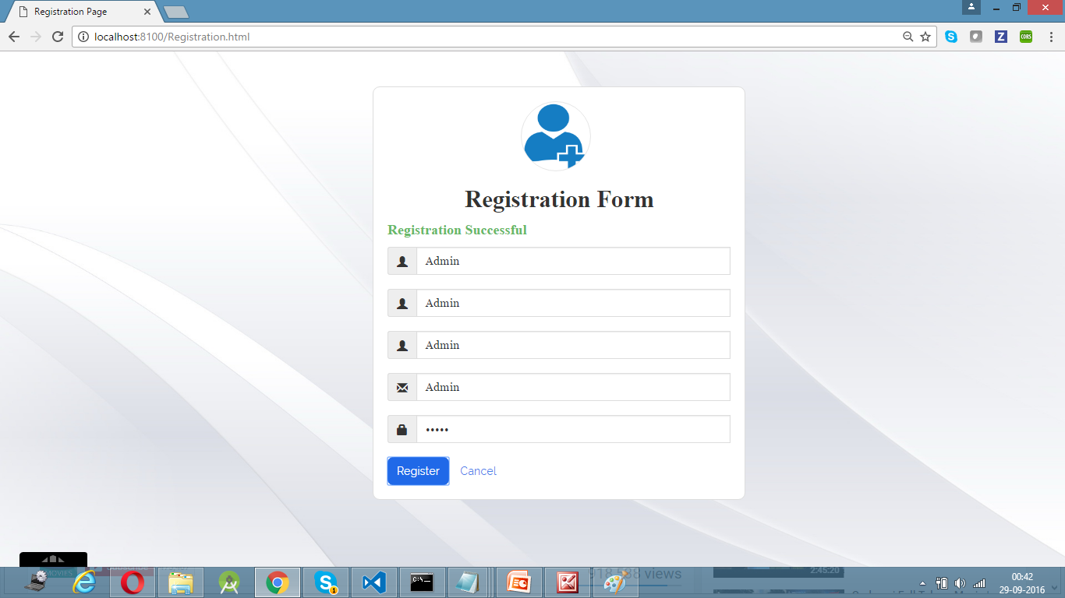

**Registration Failure Page:**

If any user with the name already has registered then your registration could not be done. It then directs to the Registration Page and display a message stating the “User Admin already exists”.

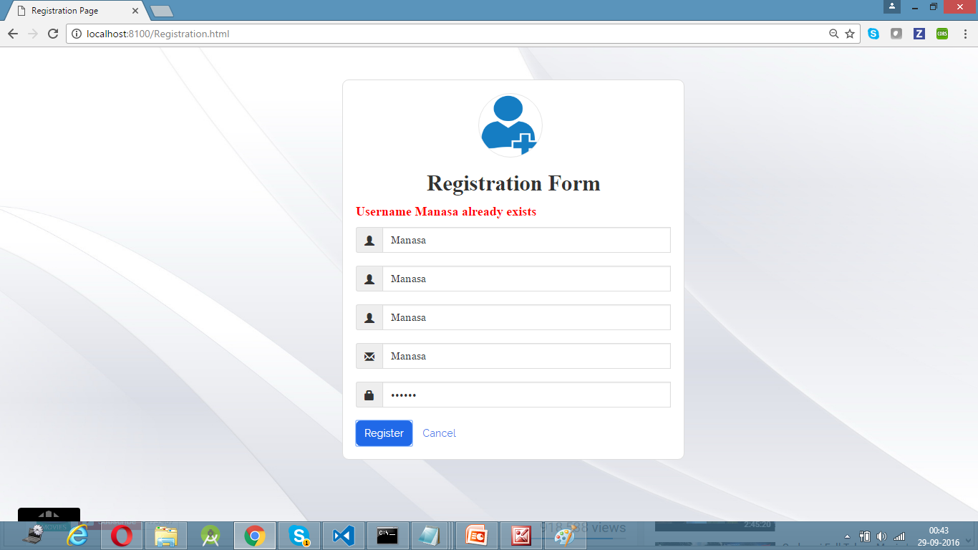

**Home page:**

The Welcome page contains the list of functionalities provided in this application that are developed using different knowledge services and web services. A brief description of each and every functionality is provided and also a link to access that particular functionality is also provided.

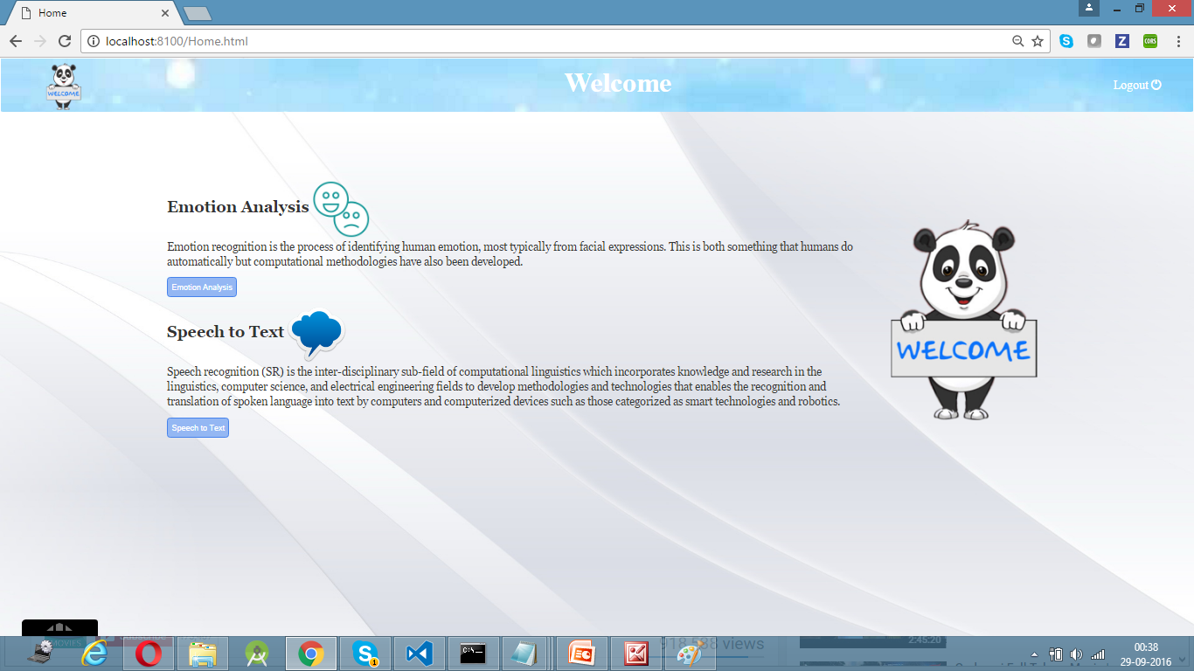

**Emotion Analysis page:**

This page contains a button to browse a file from local folder perform emotion analysis on that file. After uploading the file click on ‘Analyze’. It will take the file and process the file and returns a tabular form containing all the related to the file like type, Age, Gender, Sadness, Fear, Joy etc

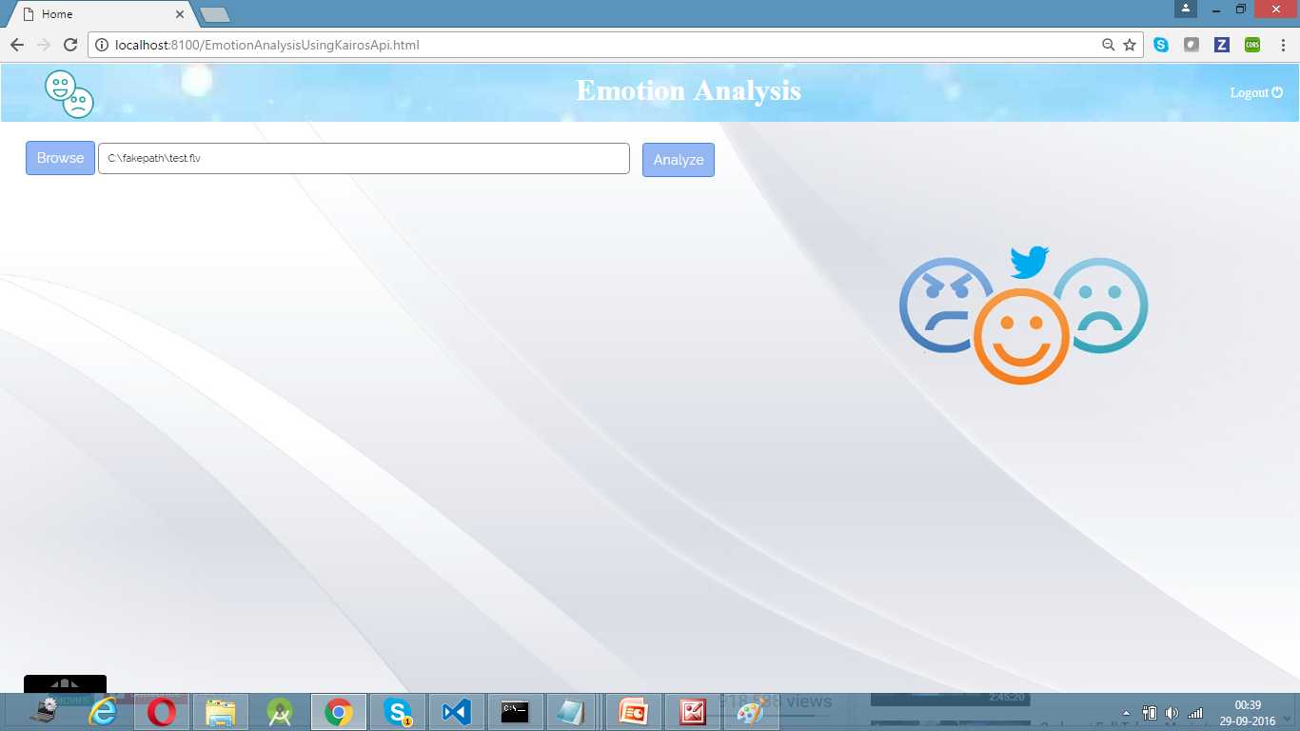

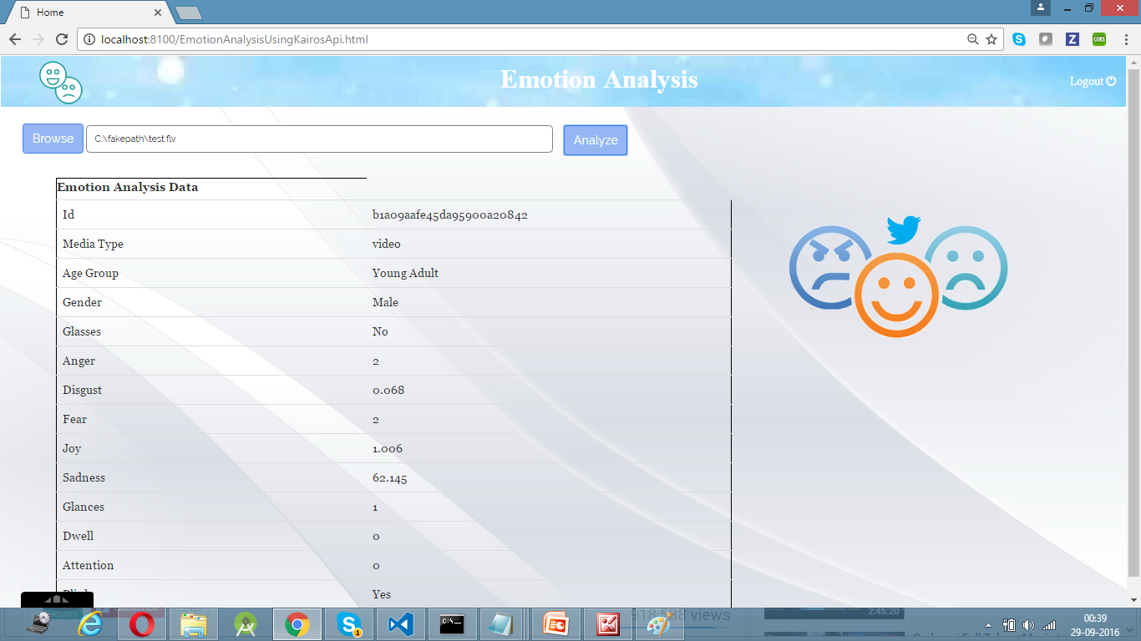

**Speech to Text Conversion page:**

This page contains a microphone, if you click on the microphone the recording starts and will display a message to start speaking all the words you speak gets displayed in the text field. Whenever you want to stop the recording click on the microphone it will stop recording. It also has an option to select a language. 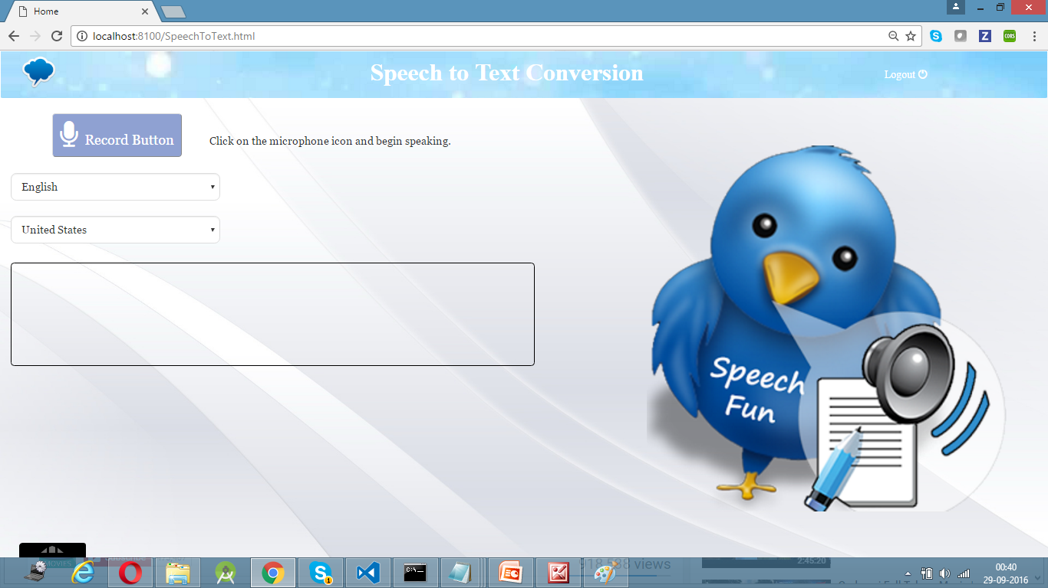

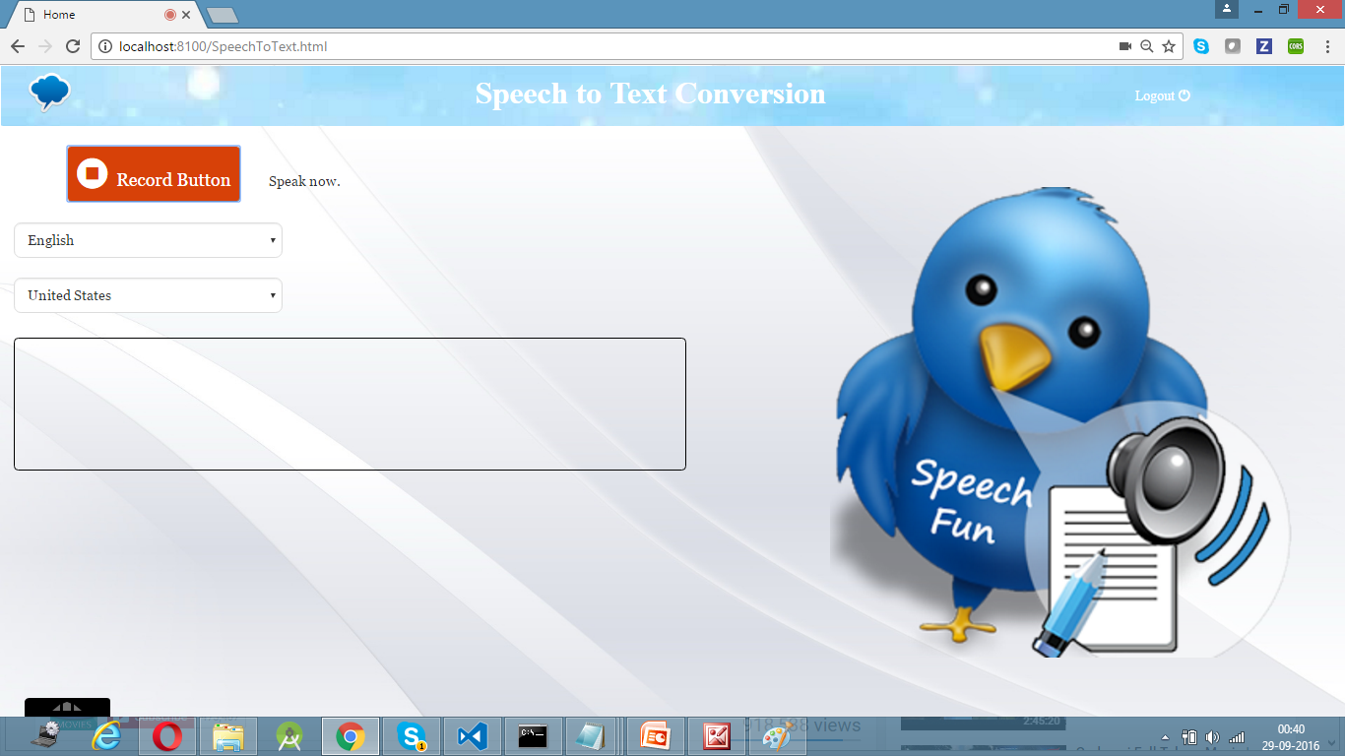

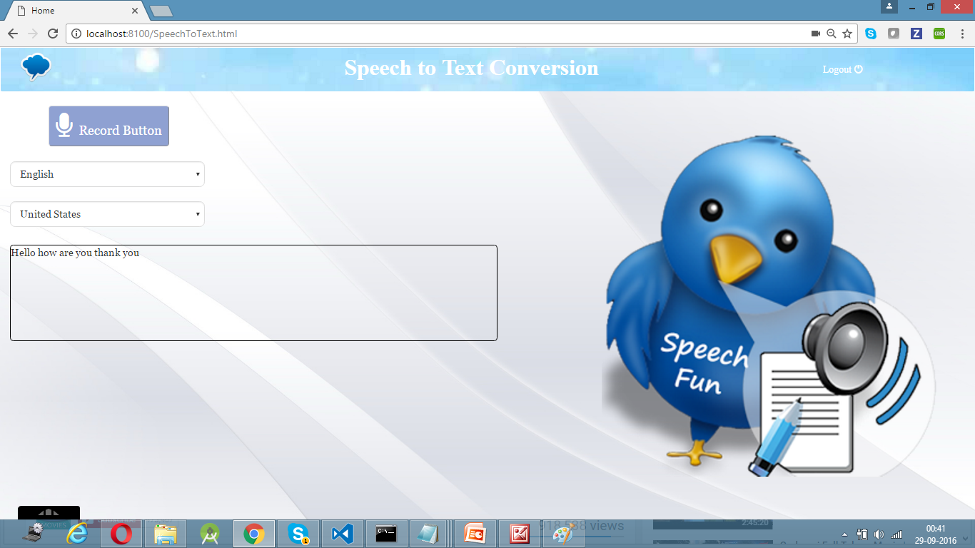

**Karma and Jasmine Test Cases:**

**TestCase 1:**

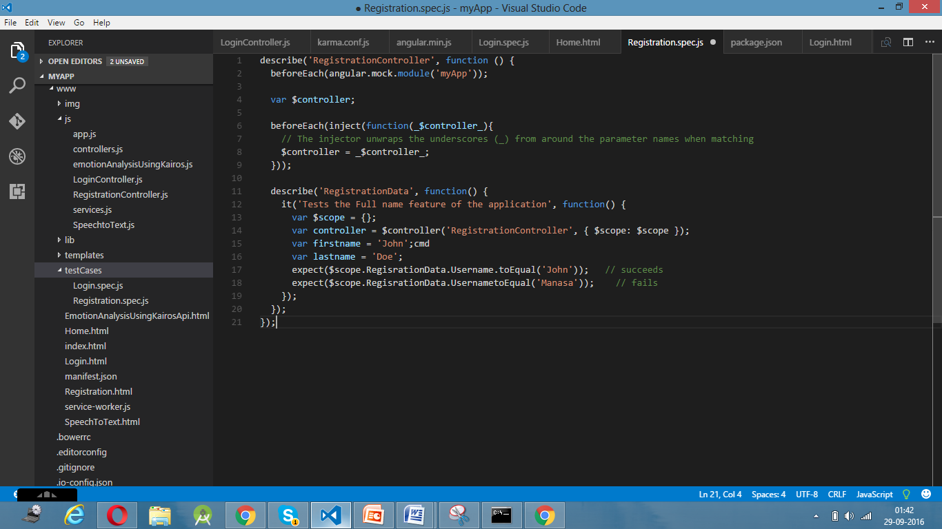

**TestCase 2:**

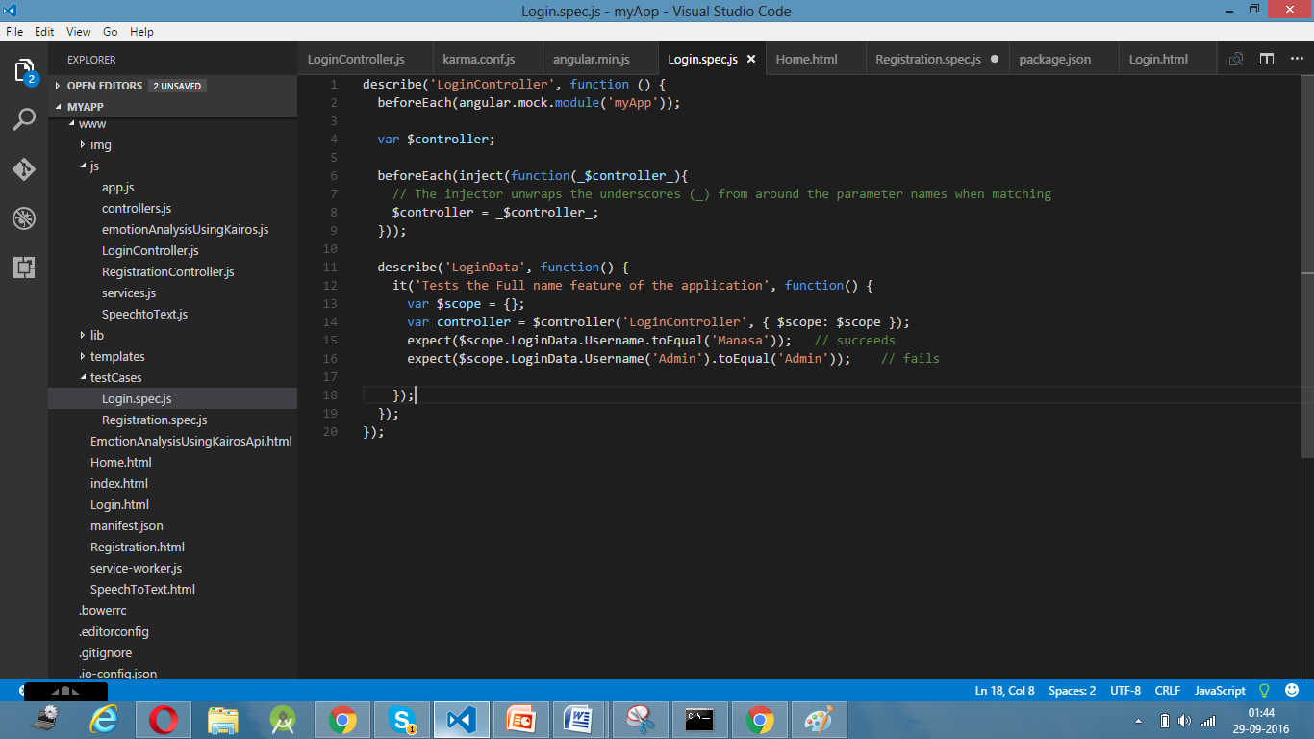

**TestCase 3:**

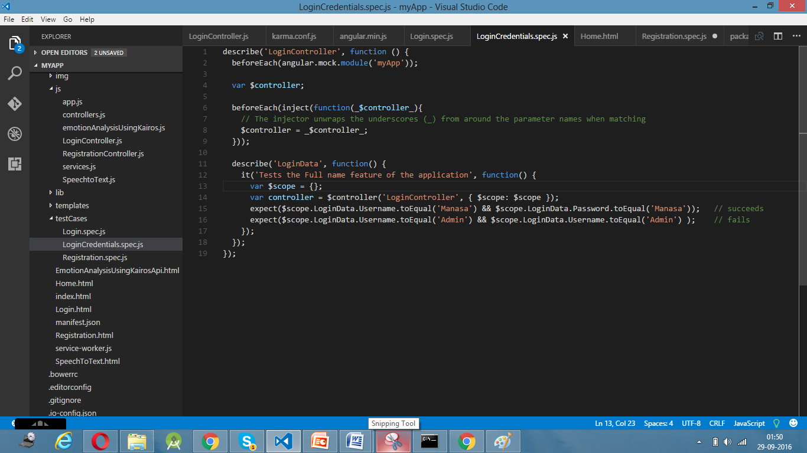

**TestCase Output:**

